R Language Assignment

1. Create a graph with 2 vectors and include 10 points each.

sol.>x<seq(2,9,2.0)

>y<seq(2,9,2.0)

>plot(x,y)

Fig-1

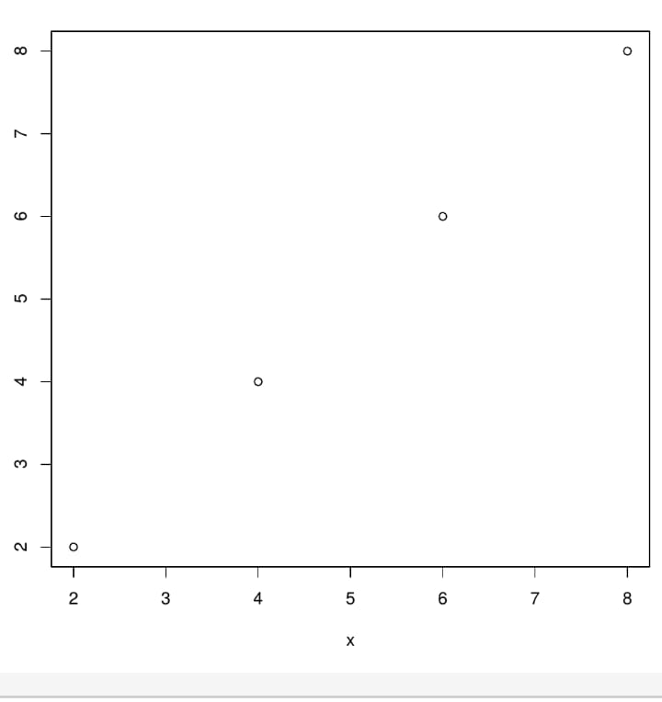

>x<-seq(2,9,2.0)

>y<-seq(2,9,2.0)

>plot(x,y)

>lmount<-lm(y~x)

>abline(lmount)

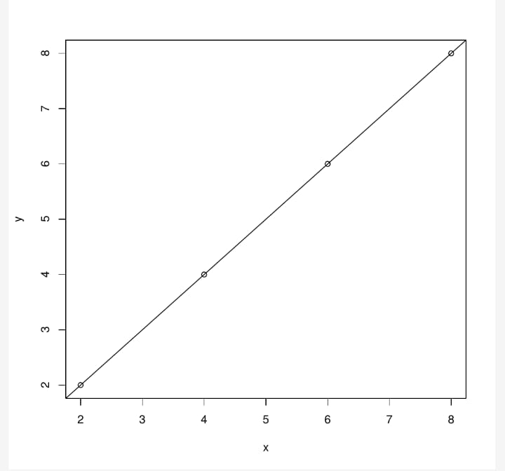

2.Explain about probability distributions and execute normal distribution in R.

sol.

Probability Distribution:

A probability distribution describes how the value of a random variable is distributed

They are four types of Probability Distributions

1.Normal Distribution

2.Poisson Distribution

3.Binomial Distribution

4.Exponential Distribution

Normal Distribution:

The normal distribution is defined by probability density function ,where μ is the population mean and mean σ2 is

the variance.

f(x)=1/(σ√2π )e^-(x-μ)2/2σ2

In particular normal distribution μ=0 and σ=1 is called stardard normal distribution and it is denoted with

N(0,1).The normal distribution is important because of central limit theorem

It can be Graphed as Follows:

In R we have Four in built functions to generate Normal distribution.

They are as follows:

dnorm(x, mean, sd)

pnorm(x, mean, sd)

qnorm(p, mean, sd)

rnorm(n, mean, sd)

Following is the description of the parameters used in above functions −

x is a vector of numbers.

p is a vector of probabilities.

n is number of observations(sample size).

mean is the mean value of the sample data. It's default value is zero.

sd is the standard deviation. It's default value is 1.

dnorm():

This function gives height of the probability distribution at each point

for a given mean and standard deviation.

x<-seq(-5,5, by = 0.1)# Create a sequence of numbers between -5

and 5 incrementing by 0.1.

y<-dnorm(x, mean = 1.5, sd = 0.5)# Choose the mean as 1.5 and

standard deviation as 0.5.

plot(x,y)

Graph:

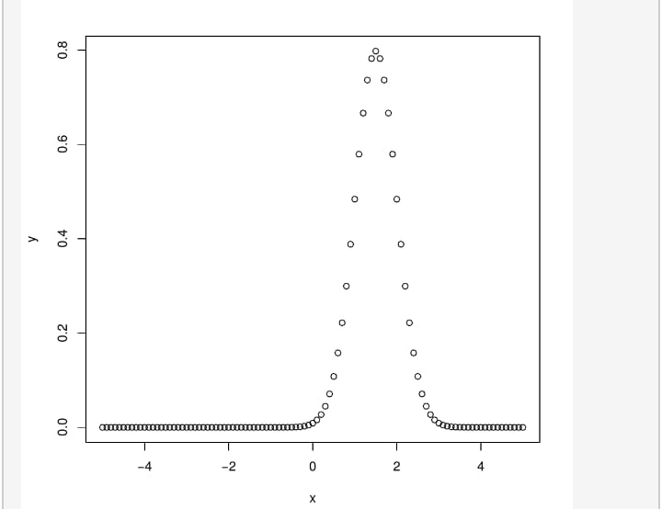

pnorm():

This function gives the probability of a normally distributed random

number to be less that the value of a given number. It is also called

Cumulative Distribution Function.

x- seq(-10,10,by =0.1)

y- pnorm(x, mean = 1.2, sd = 2)

plot(x,y)

Graph:

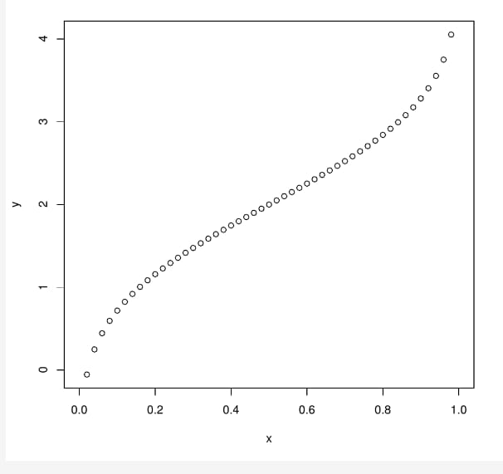

qnorm():

This function takes

the probability value and gives a number whose cumulative value matches the

probability value.

x<-seq(0,1, by = 0.02)

y<- qnorm(x, mean = 2, sd = 1)

plot(x,y)

Graph:



rnorm():

This function is used to generate random numbers whose distribution is normal.

It takes the sample size as input and generates that many random numbers. We draw a histogram to show the distribution of the generated numbers.

y <- rnorm(35)

# Plot the histogram

hist(y, main = "Normal Distribution")

Graph:

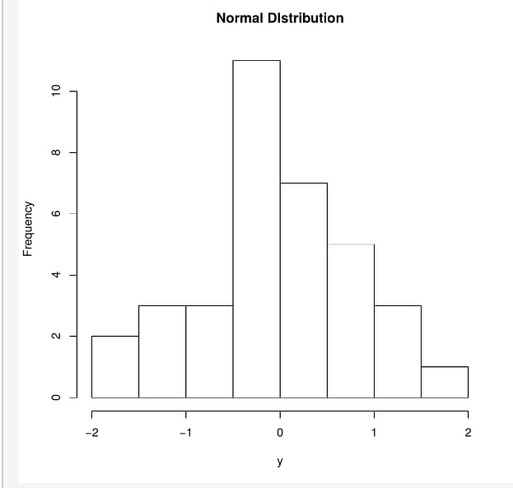

3. Execute binomial distribution and create histograms with sizes of 1 to 10 and prob 0.1 to 0.9 each with n value 10.

sol:

Binomial Distribution:

Binomial distribution is a discrete probability. It describes the outcome of n independent trails in an experiment.

R has four in-built functions to generate binomial distribution. They are described below:

1.dbinom(x, size, prob)

2.pbinom(x, size, prob)

3.qbinom(p, size, prob)

4.rbinom(n, size, prob)

Following is the description of the parameters :

x is a vector of numbers.

p is a vector of probabilities.

n is number of observations.

size is the number of trials.

prob is the probability of success of each trial.

dbinom():

This function gives the probability density distribution at each point.Create a sample of 100 numbers which are incremented by 2.

x<- seq(0,100,by = 2)

# Create the binomial distribution.

y<- dbinom(x,100,0.5)

# Plot the graph for this sample.

plot(x,y)

Graph:

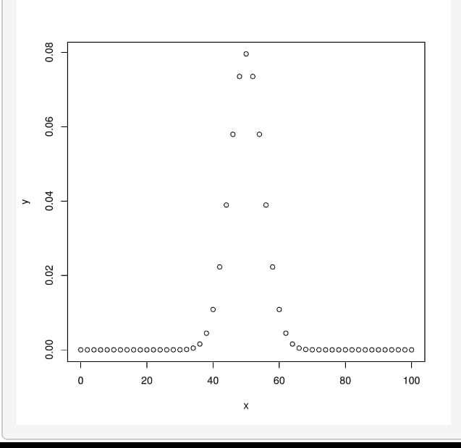

pbinom():

This function gives the cumulative probability of an event. It is a single value representing the probability.

# Probability of getting 30 or less heads from a 100 tosses of a coin.

x<- pbinom(30,100,0.5)

print(x)

Example:

x<-pbinom(15,50,0.1)

print(x)

Output:

[1] 0.9999825

qbinom():

This function takes the probability value and gives a number whose cumulative value matches the probability value.

Example:

x<-qbinom(0.17,100,1/2)

print(x)

Output:

[1] 45

rbinom():

This function generates required number of random values of given probability from a given sample.

Example:

x <- rbinom(10,100,0.3)

print(x)

Output:

[1] 34 33 36 29 28 31 27 31 28 34

PLOTTING HISTOGRAMS:

x=c(1,2,3,4,5,6,7,8,9,10)

hist(x,prob=0.9,n=10)

HISTOGRAM:



Done By:

B.Geethika Sindhu

18HP1A1208